SPECIFICATION FOR SUPPLY AND DELIVERY OF WEHD DISTRICT BUILD-UP MATERIALS AND SUPPLIES

BOQ

Number | Description | Quantity | Unit Price | Amount
1 | Posters  150 X A3 with the following written on it  - Heading: HYGIENE REQUIREMENTS FOR FOOD PREMISES  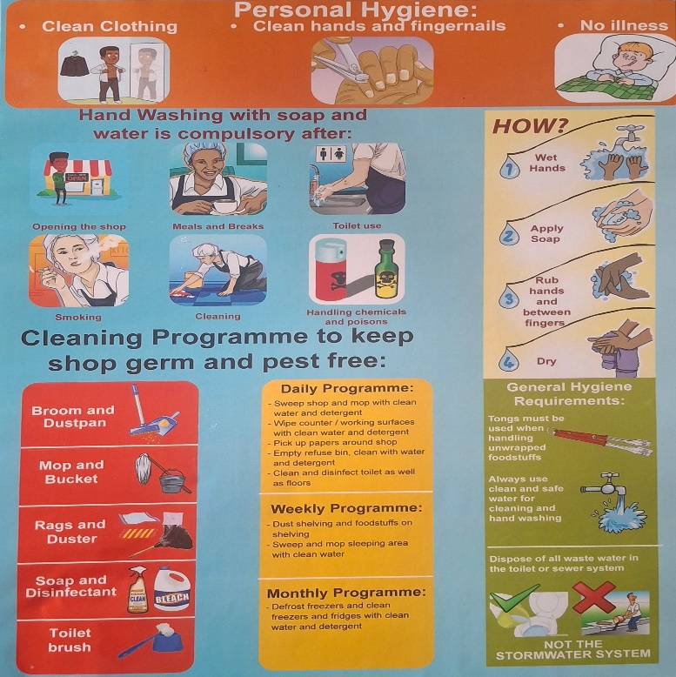  150 X A3 with the following written on it, with illustration stating the following is not allowed:  - Sleeping in a room where food products are stored and sold  - Storing a bed or bedding in a room where food products are stored and sold  - Personal clothing hanging or lying on foodstuff and shelves  - Washing and ironing of laundry  - Preparing meals for personal consumption in a room where food products are stored and sold  - Food products store in direct contact with floor surface  - Selling food stuffs without proper labelling or decanted products  - Food products with damaged packaging, leaking or bloated  - Open or unmarked poisonous/ hazardous products  - Pests like flies, cockroaches, mice and rats  - Animals and pets  - Dirty hands, fingernails and clothing  - Uncovered open wounds and sores on the body  - Coughing, sneezing and spitting over food products  - Smoking not allowed inside premises  - Disposal of refuse and including boxes, packaging materials and paper on open spaces or in any manner that will pollute the environment  - Burning of refuse  - Disposal of waste water on the street or in storm water drains  - Storage of unnecessary items in food premises | 300
2 | Booklet  To have the following detailed (service provider must consult Municipal Health Services)  Definition of  - Municipal Health Services  - Water quality monitoring  - Food control  - Waste Management  - Health Surveillance of premises  - Surveillance and prevention of communicable diseases, excluding immunizations  - Vector control  - Environmental pollution control  - Disposal of the dead  - Chemical safety | 150
3 | Pamphlets /Leaflets/ Brochures  The following to be on the pamphlet/leaflet/brochure and illustrated  Slogan: “Clean Air, Healthy People” Breathe better. Live Better. | 3000
Total Exclusive VAT
VAT @ 15%
Total Inclusive VAT

- All items must be SABS approved.

NB: An appointed service provider will be requested to bring and present samples of all sizes for shoes, lab coats and safety shoes for fitting purposes and quality. Goods will not be accepted if they are not as required, and that will result in non-payment.

Price and Preference
Quotations will be evaluated according to the 80/20 Point System in compliance with Preferential Procurement Policy Act (5/2000) and Preferential Procurement Regulations 2022.
This project will be evaluated based on the below criteria:
Preferential  Procurement Goals | Proof to be Attached to Claim full Points | Points
Price | N/A | 80
Specific Goal |  | 20
Bidders will score Specific Goals as follows
Empowerment of Women | Attach ID Certified Copies of Directors Claiming Specific Goals; for Bidders to obtain full points the percentage of equity held must be 51% or more | 5
Youth | Attach ID Certified Copies of Directors Claiming Specific Goals; for Bidders to obtain full points the percentage of equity held must be 51% or more | 5
Rural | Attach Proof of Residence of the Business or Lease Agreement | 3
Disabled | Attach Signed Letter from Health Practitioner | 3
Black Owned Companies | Attach CK and ID Certified Copies of Directors Claiming Specific Goals; for Bidders to obtain full points the percentage of equity held must be 51% or more | 4
Total Scoring |  | 100

SUBMISSION OF quotations
Quotations must be placed in a sealed envelope and clearly marked: “Laboratory Analysis Protective Clothing (MHS)” and placed in the Bid box in the Alfred Nzo District Municipality not later than 12H00

__________________________________
RECOMMENDED BY:
MR O DIKO
DIRECTOR: COMMUNITY DEVELOPMENT SERVICES

DATE: ……………………….

________________________________
APPROVED BY:
MR O DIKO
ACTING MUNICIPAL MANAGER

DATE OF APPROVAL …………………………………………….
COMMENTS: ______________________________________________________________________________________________________________________________________

